**Managing Windows Server with Puppet**

Step 1: Open Microsoft Azure Portal

<https://portal.azure.com>

Step 2: search for **Puppet Enterprise 2018.1.8**

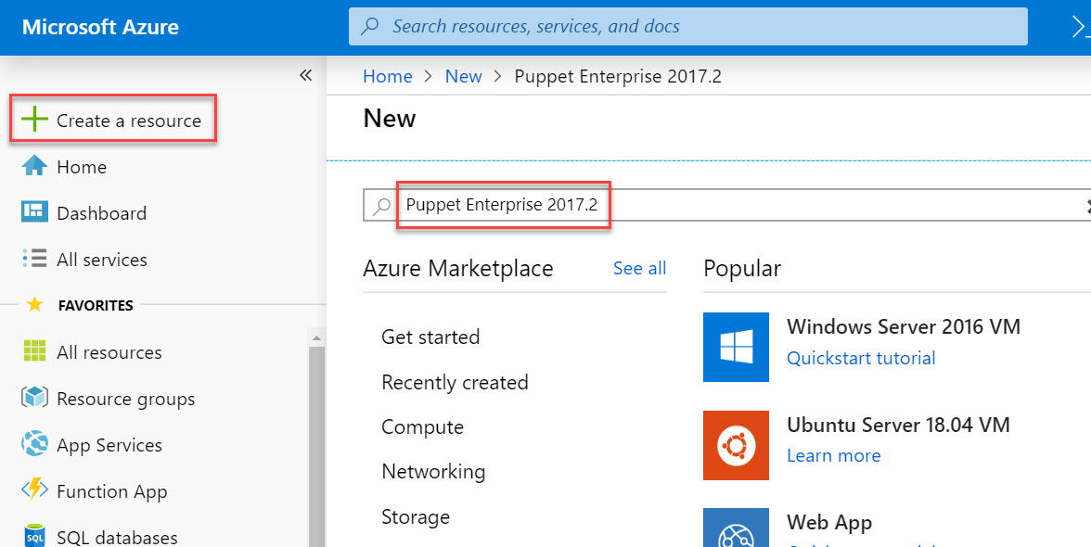

Step 3:Click on Create

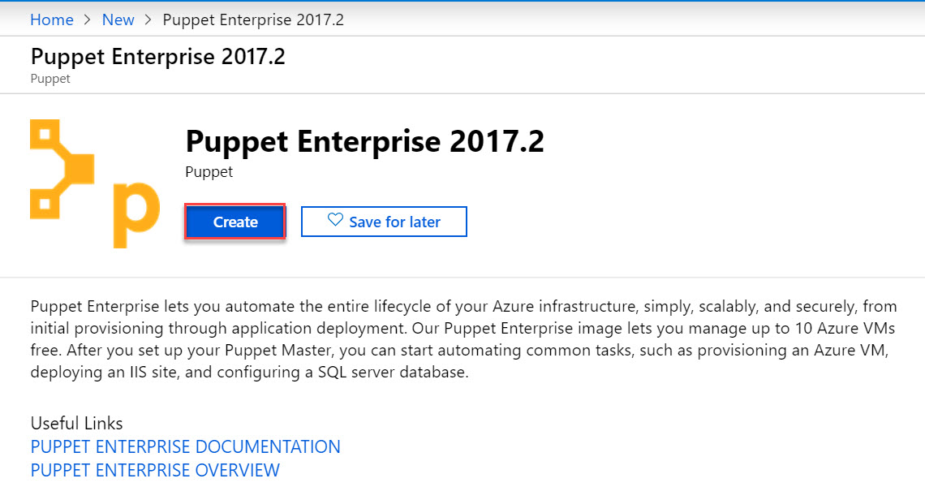

Step 4: Enter details

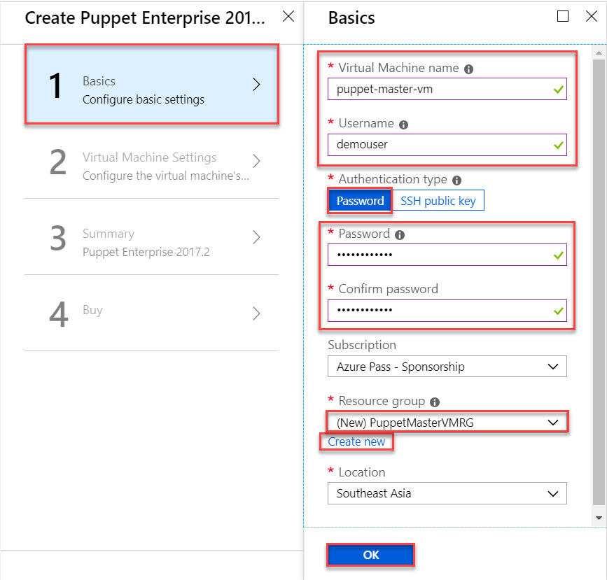

Step 4:

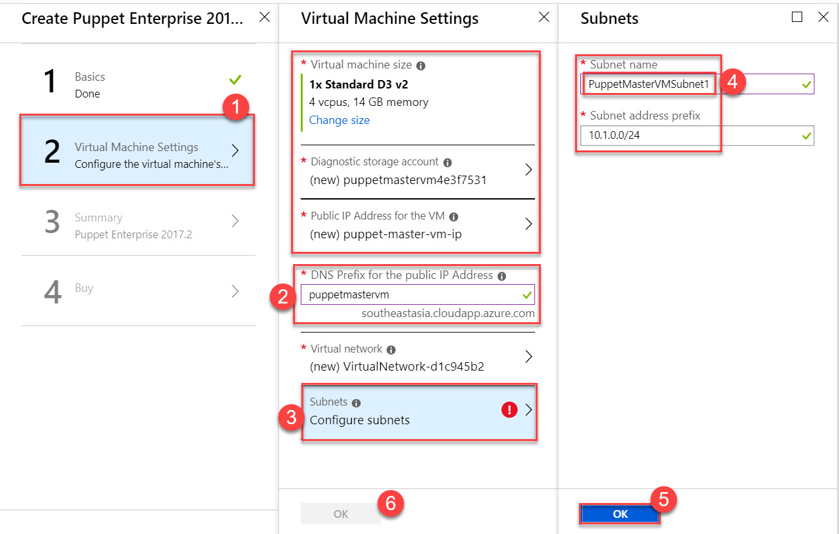

Step 5: Click on OK button.

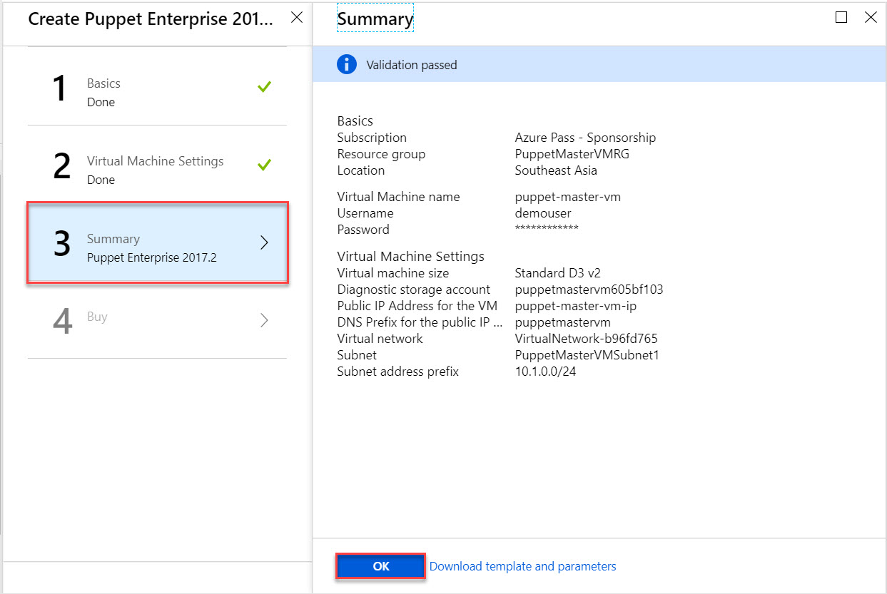

Step 6: Click on Create

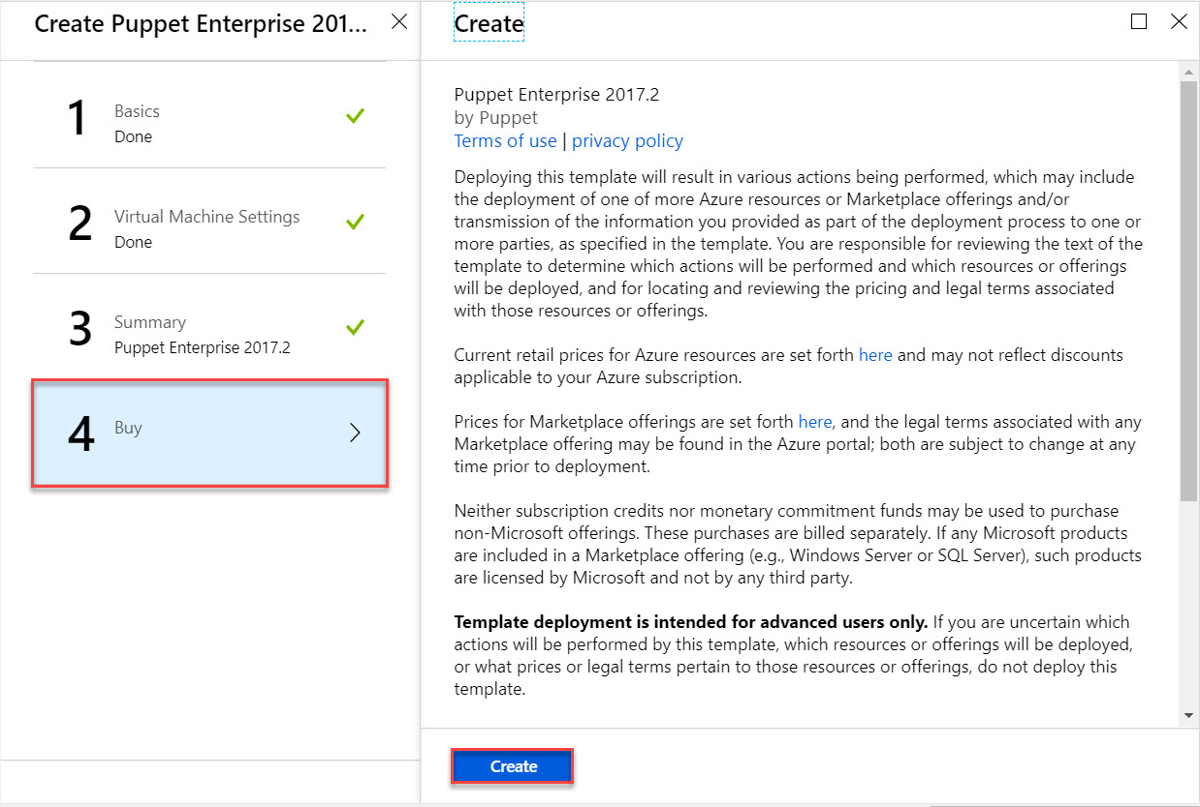

Step 7: Open Resource Group and click on Virtual Machine

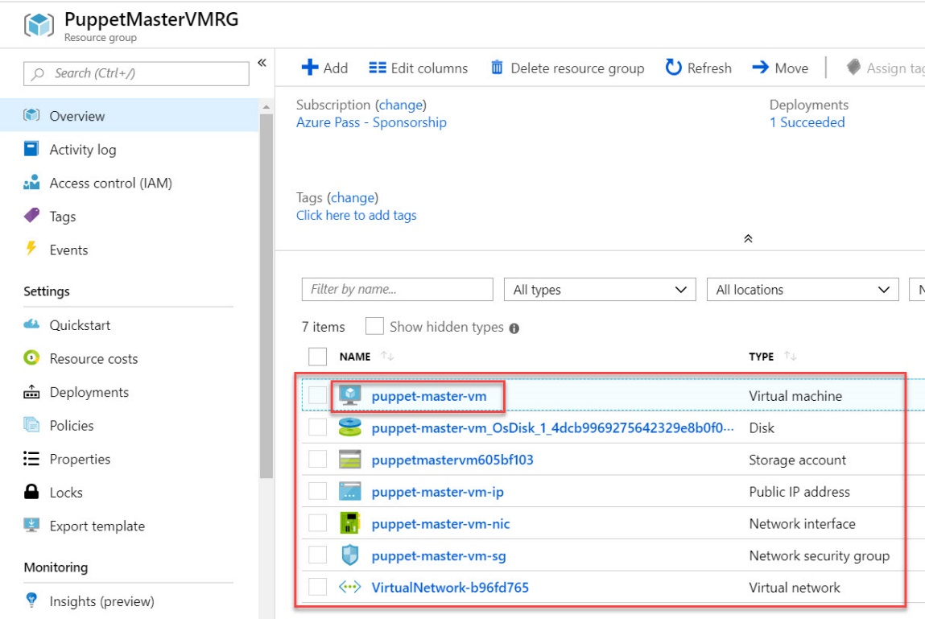

Step 8: Check DNS Name

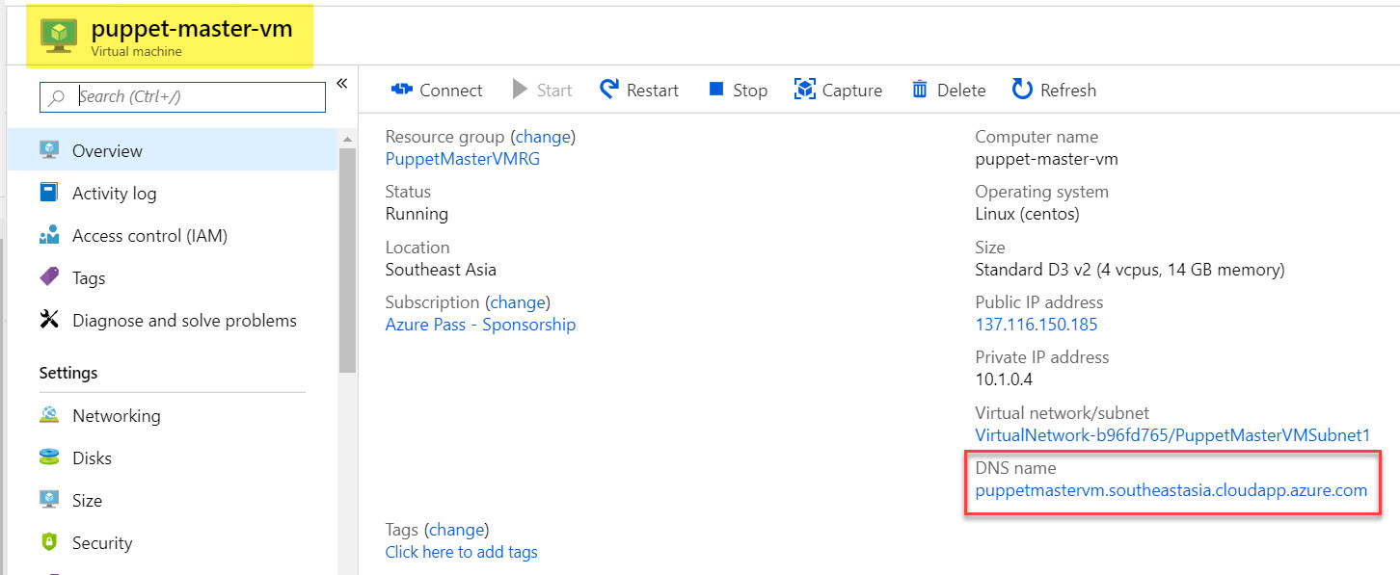

**Provision Windows Server with Puppet Agent**

Step 9: + Create a resource -> Get Started -> Windows Server 2016 Datacenter

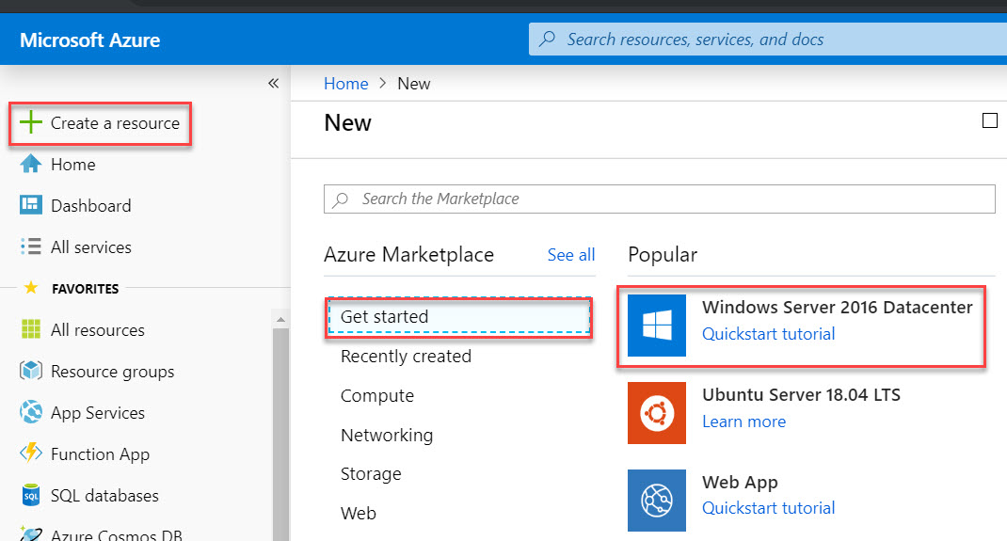

Step 10: Create Virtual Machine & Enable RDP

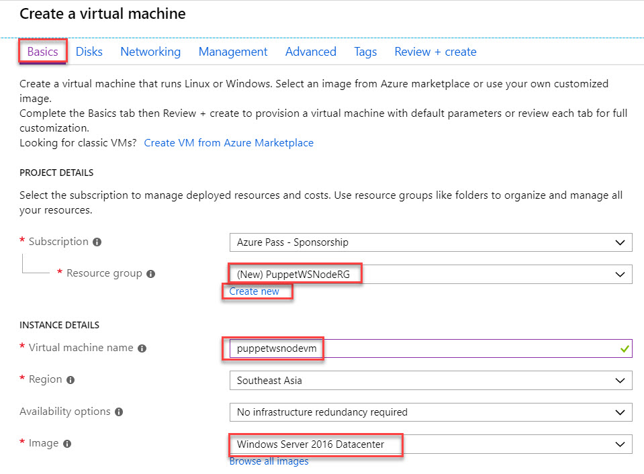

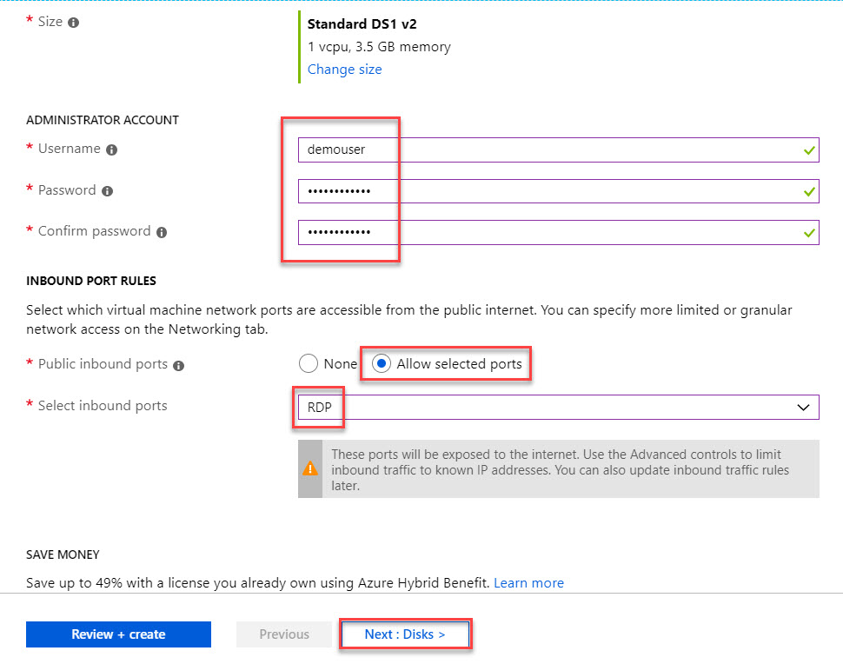

Step 11: Standard HDD

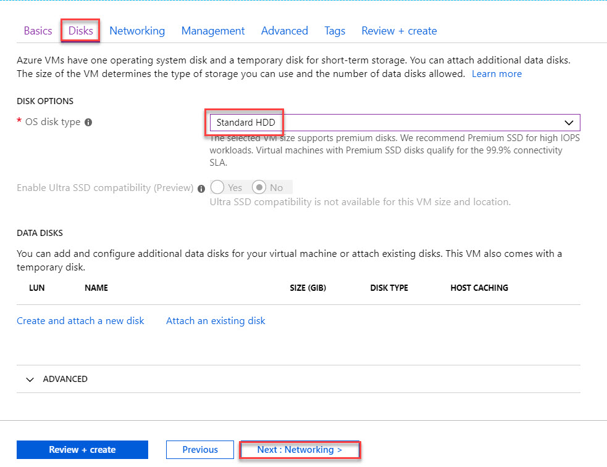

Step 12: Networking -> Next

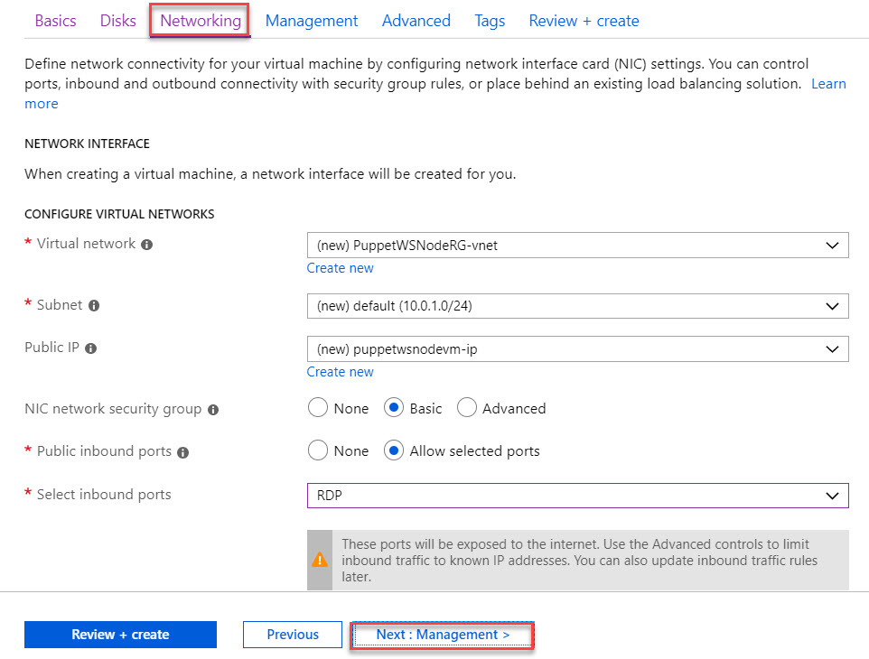

Step 13: Management -> Next

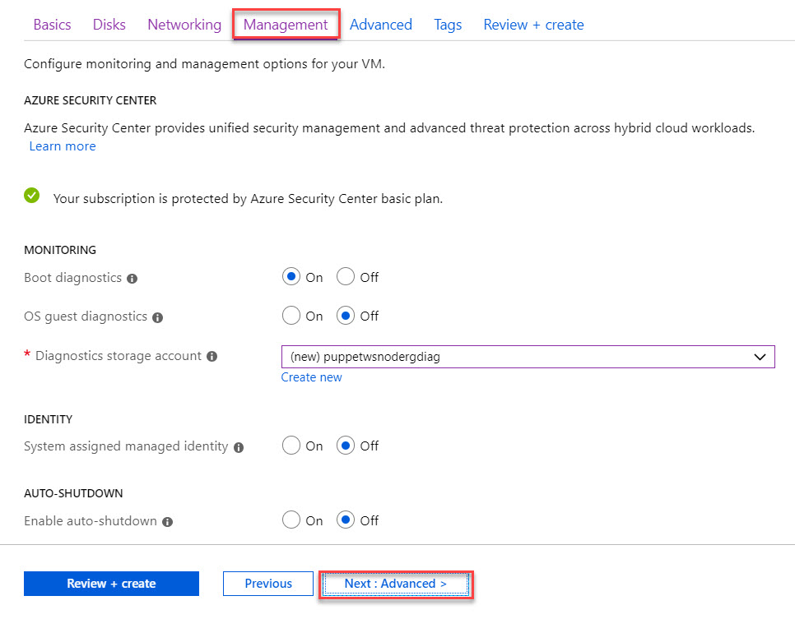

Step 14: Advanced tab click on Select an extension to install

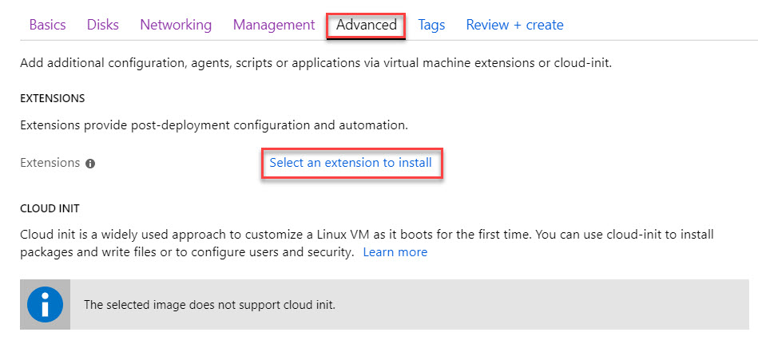

Step 15: Select Puppet Agent

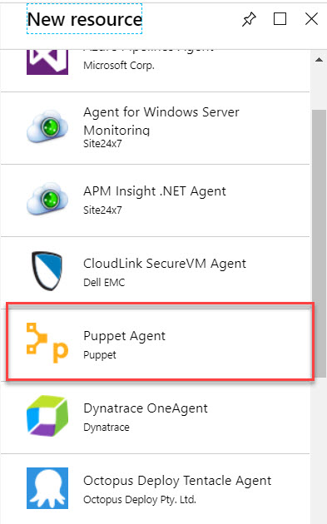

Step 16: Click on Create

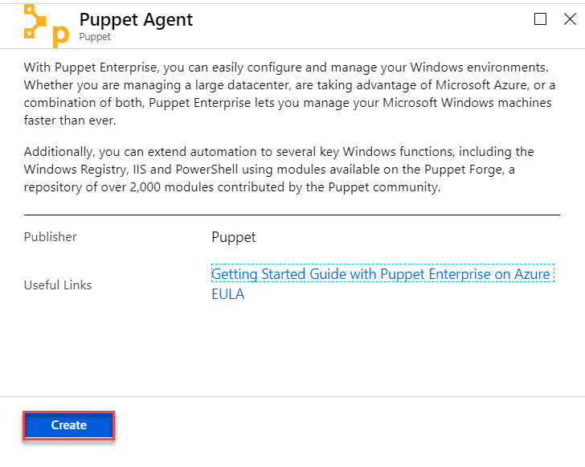

Step 17: Copy Master VM DNS Name to extension

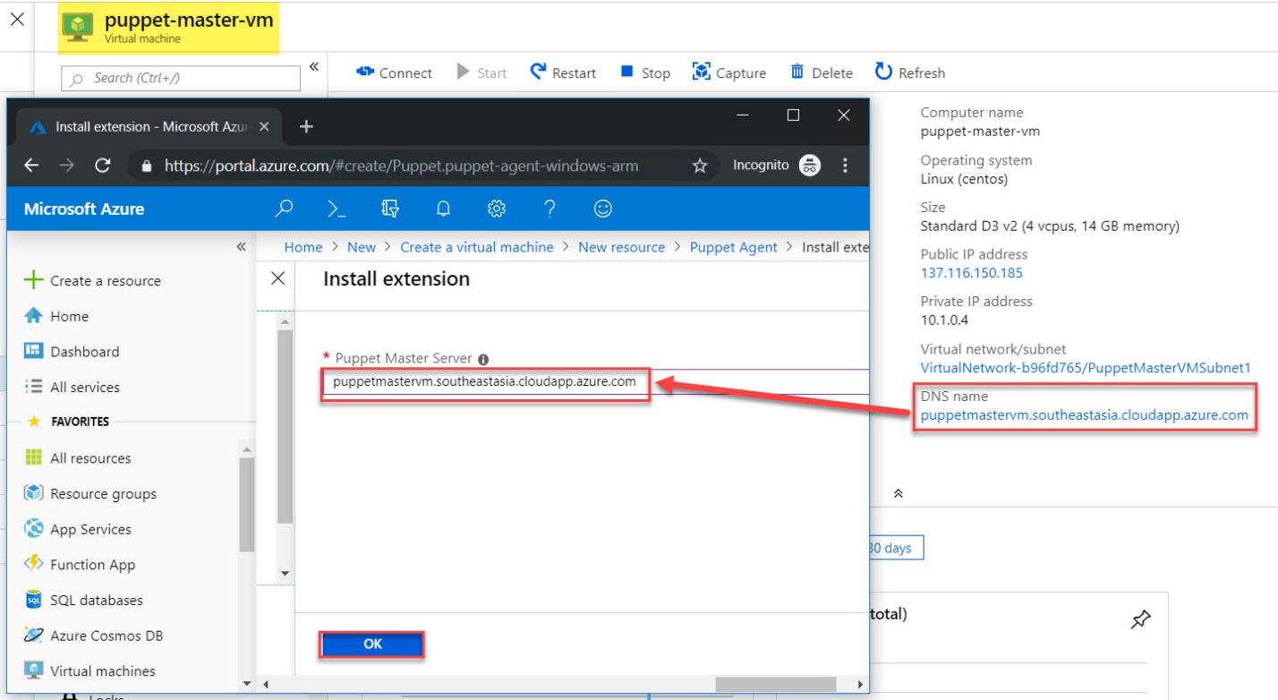

Step 18: Verify and click on Next

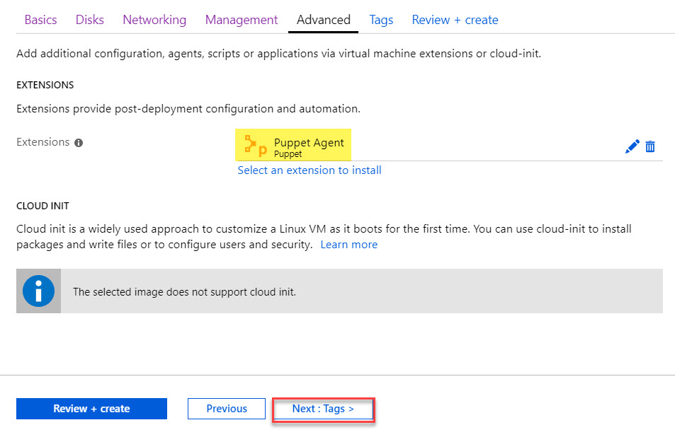

Step 19: Click on Next

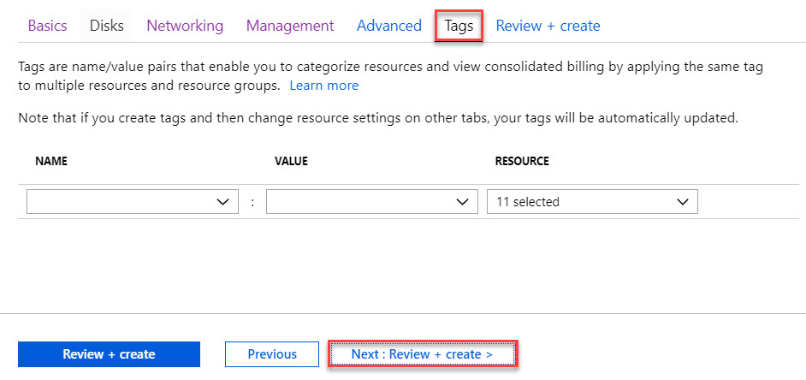

Step 20: Click on Create button.

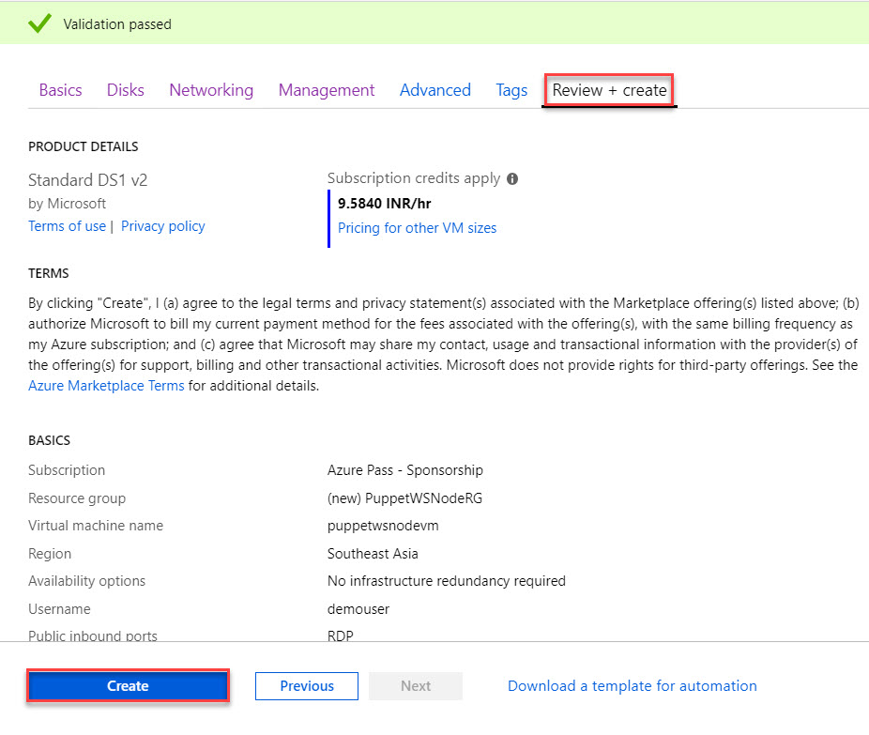

Step 21: Open PuTTy and enter master vm dns name

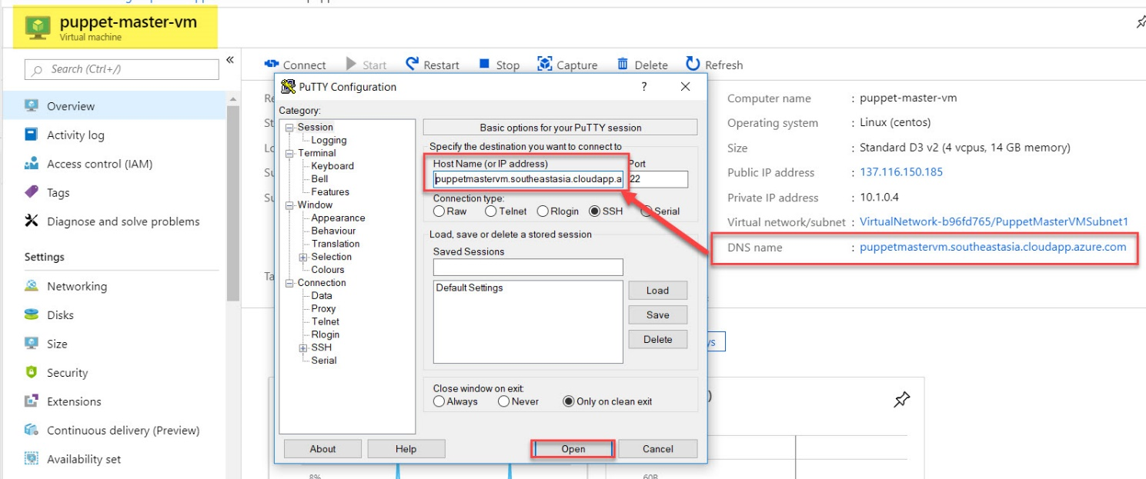

Click on Yes.

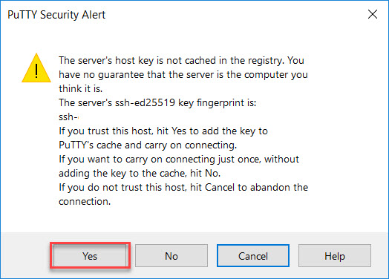

Enter username & password

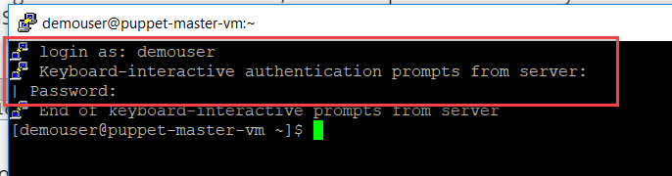

Step 22:

set_console_admin_password.rb script to change the admin user’s password for the Puppet Console.

sudo /opt/puppetlabs/puppet/bin/ruby /opt/puppetlabs/server/bin/set_console_admin_password.rb demo@pass123



Step 23: Copy DNS Name of Master VM

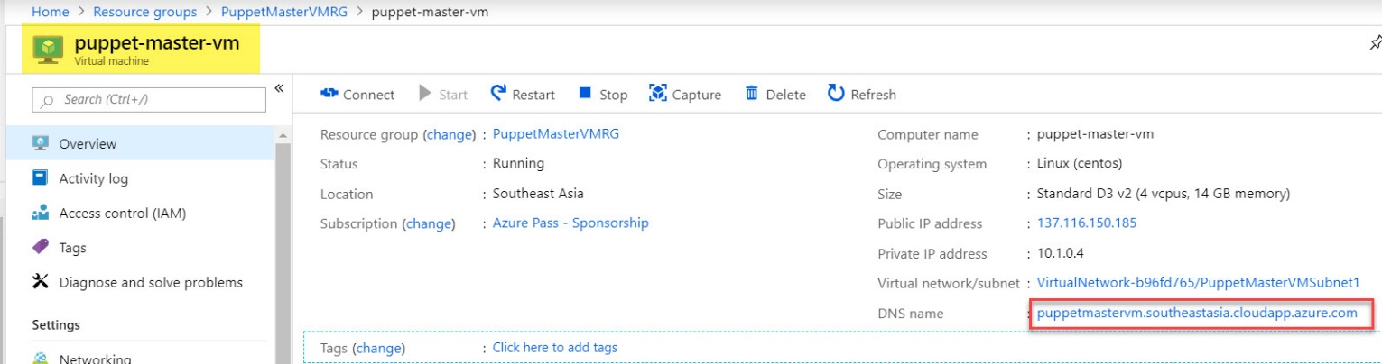

Open browser and add https://dnsname.



Step 24:

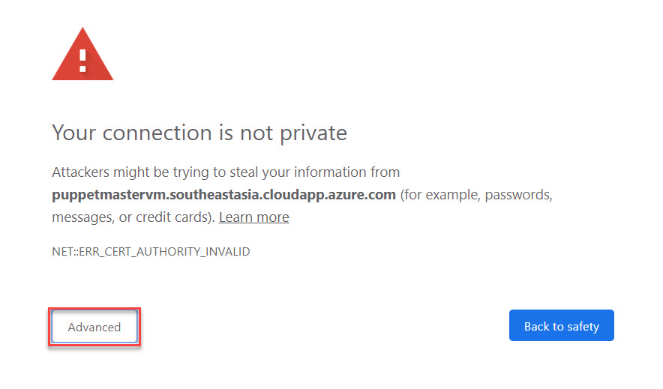

Click on Proceed

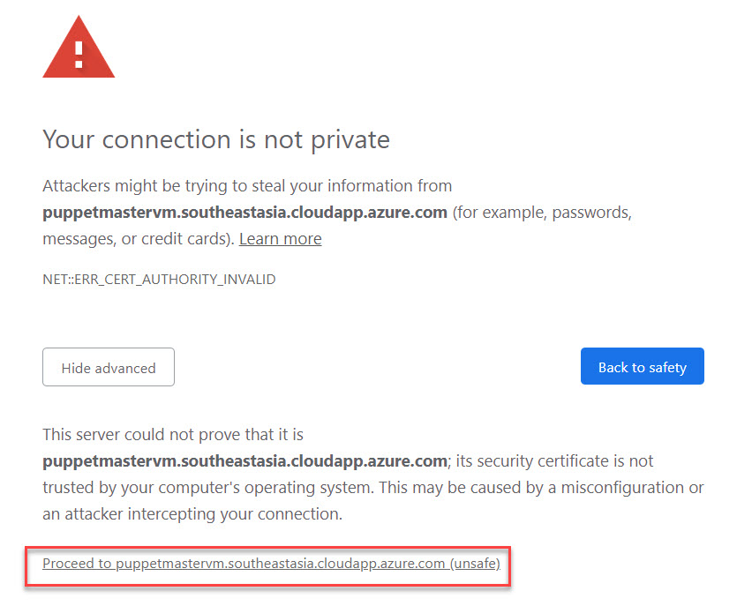

Step 25: Enter username: admin

Password: Demo@pass123

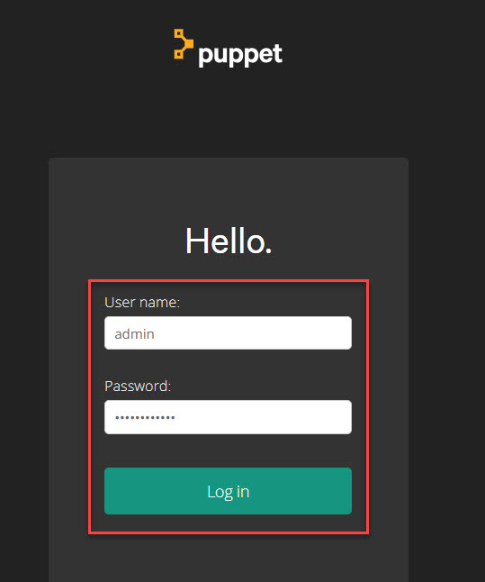

Step 26: Puppet Overview windows

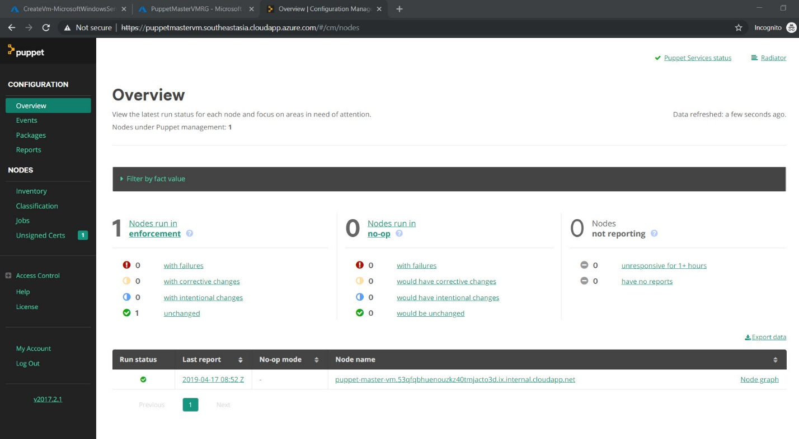

Step 27: Select Unsigned Certs and click on Accept

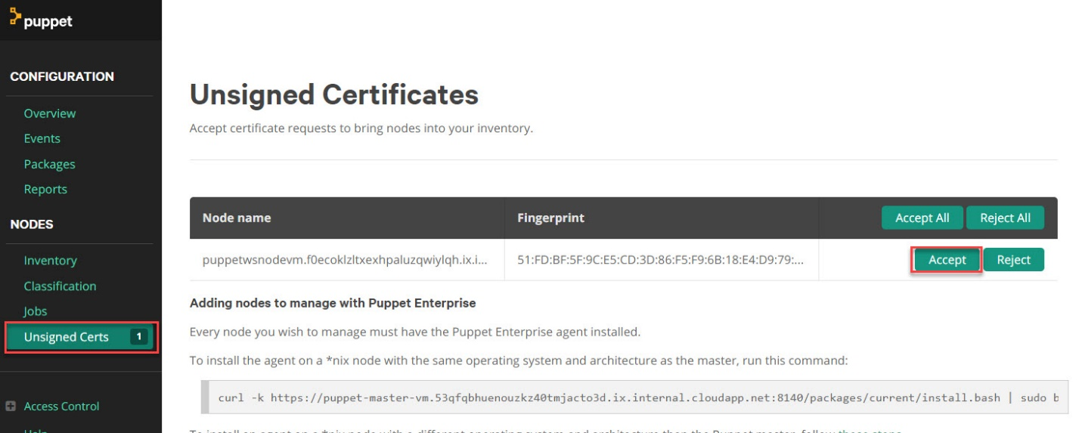

Step 28: wait for few minutes to update node vm

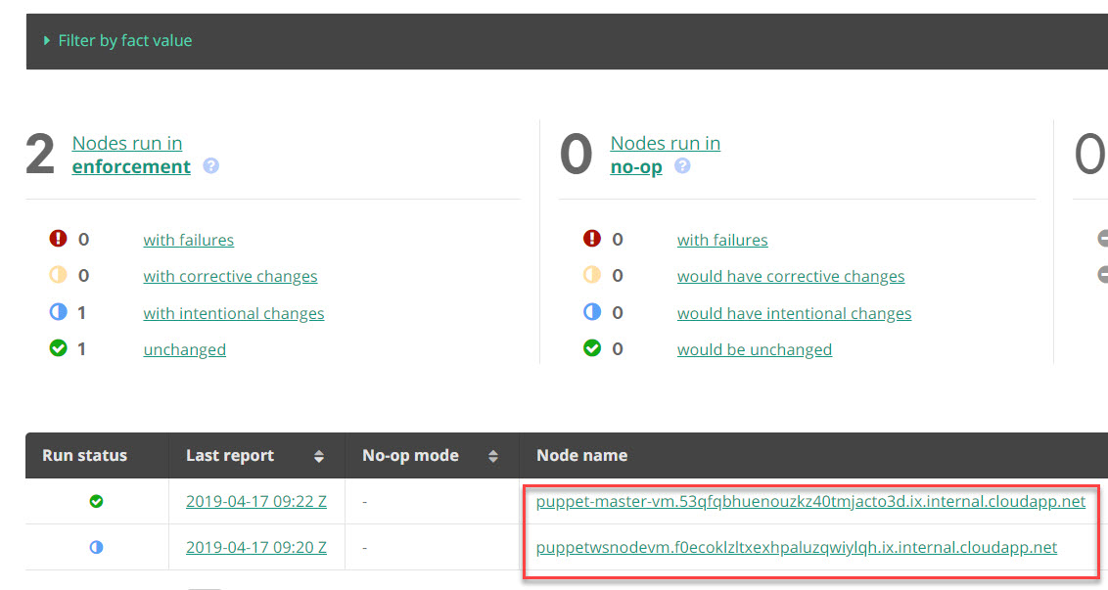

Step 29: navigate to Node VM and click on Connect button.

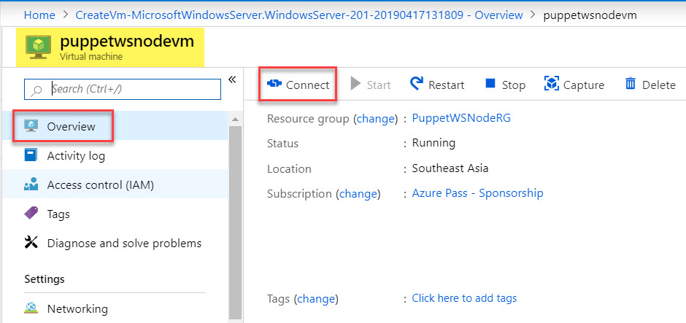

Download RDP File

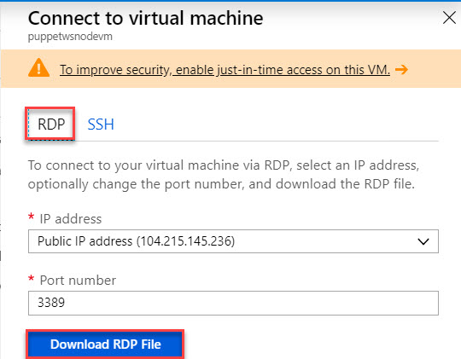

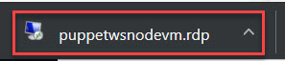

Step 30:

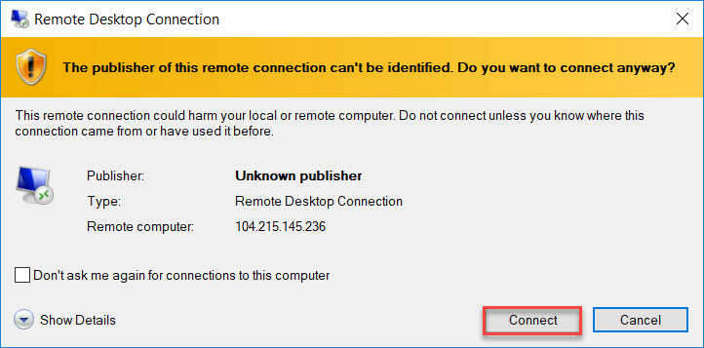

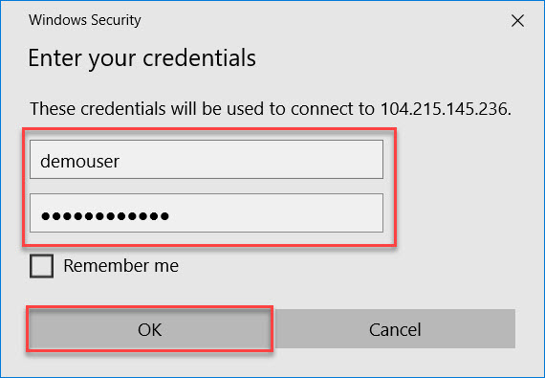

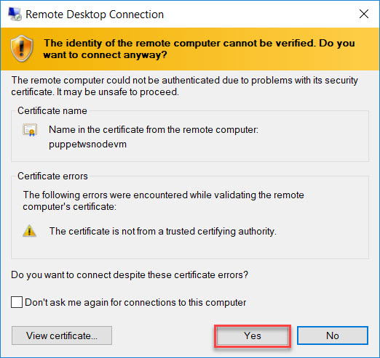

Step 31: Open Command prompt and type below command to check Agent/Master Connectivity

puppet agent -t

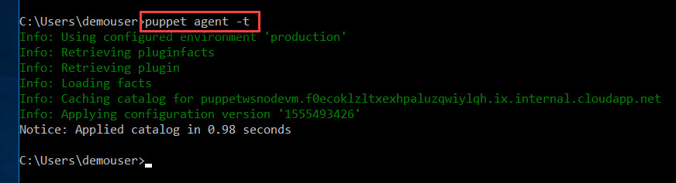

Step 32: Navigate to PuTTy or Master VM

sudo -i

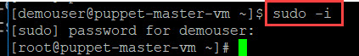

Step 33: Install the Puppet on Windows Module Pack

puppet module install puppetlabs/windows

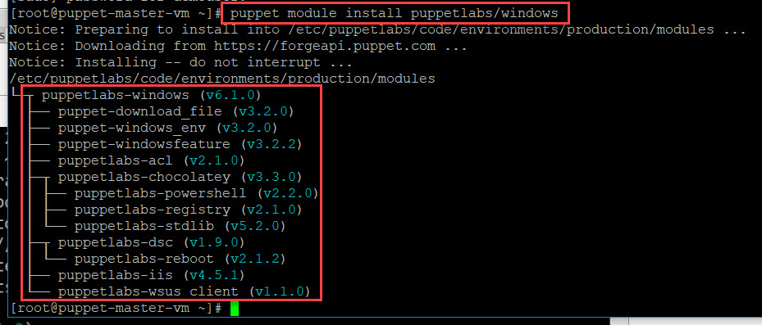

Step 34: Edit the site Manifest

Puppet uses a manifest to apply catalogs to nodes. A manifest is a program that contains Puppet DSL (domain-specific language) code. The site manifest is the starting point that Puppet master uses to apply catalogs. You can have more than one manifest, but for the purposes of this article, we will put all our code into the site manifest.

cd /etc/puppetlabs/code/environments/production/manifests

vi site.pp



Step 35: Navigate to node default class

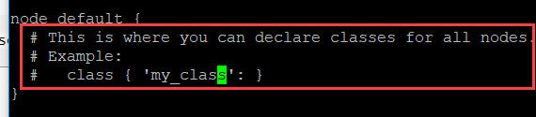

Press **i**

Add below code

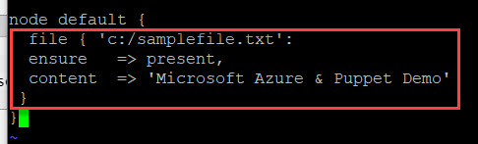

Press **Esc** to exit insert mode

**Shift + Q** -> Save file

**wq** -> write and quit

Step 36: Navigate to Node VM or Windows Server VM run agent command

puppet agent -t

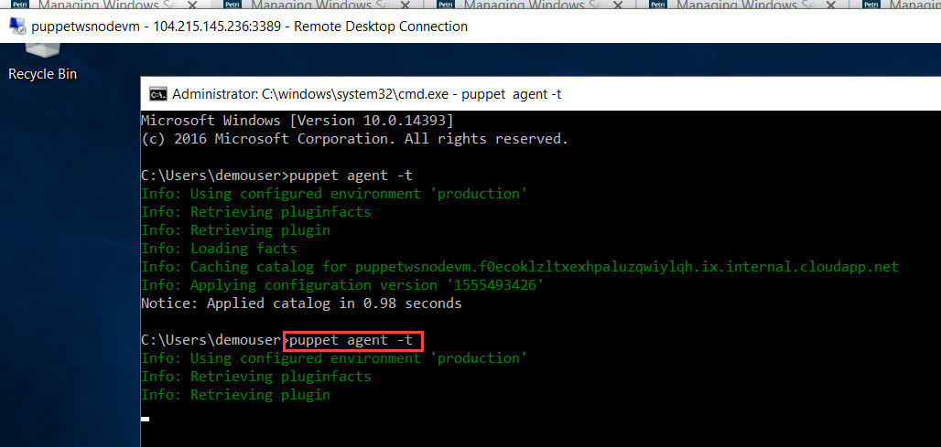

Step 37: Verify C Drive for samplefile.txt

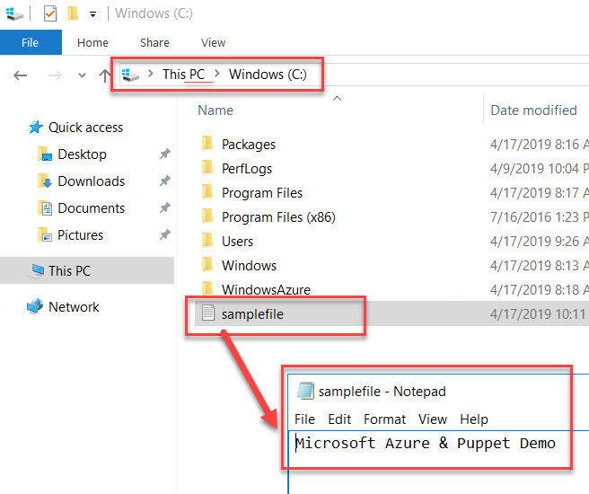

**Working with Files and Folders**

Step 38: vi site.pp



Modify with absent it will delete file

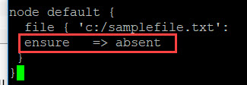

Navigate to Node vm and run

puppet agent -t

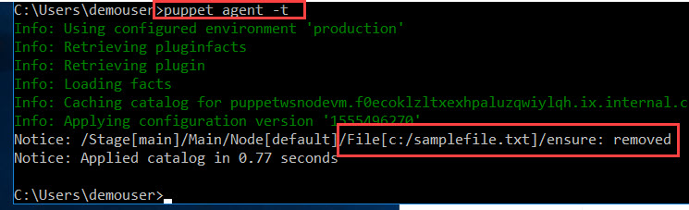

removed

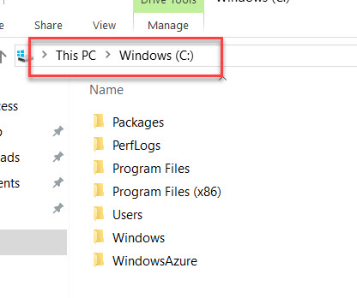

Step 39: Create Multiple files

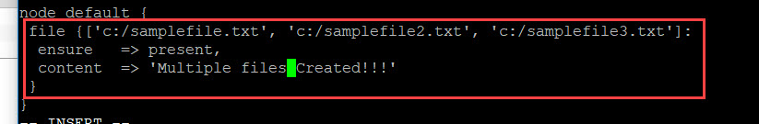

Run the agent puppet agent -t

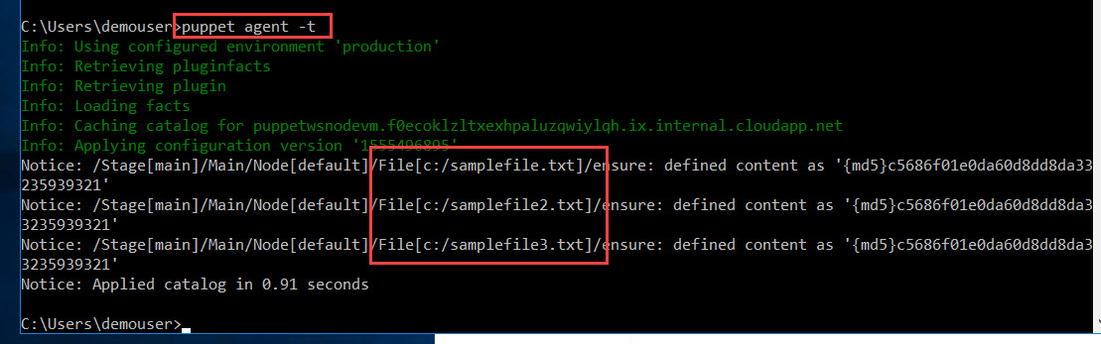

Step 40: Multiple files created

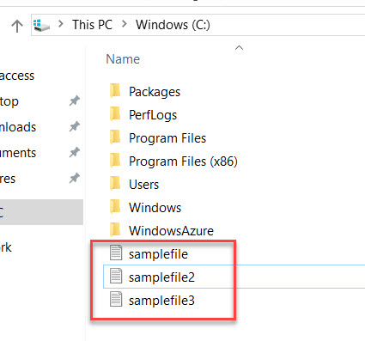

Step 41: Create multiple folders

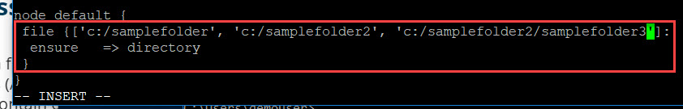

puppet agent -t

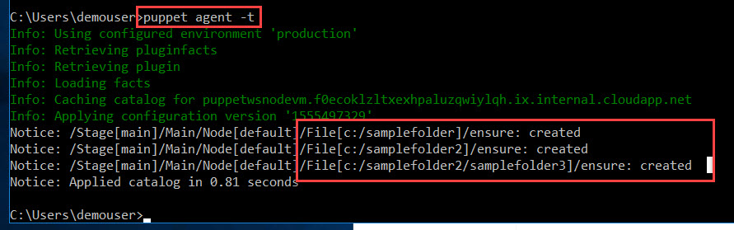

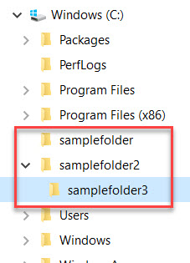

Managing Local Users and Groups

Step 42:

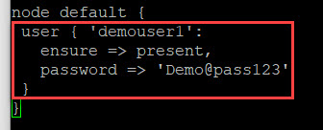

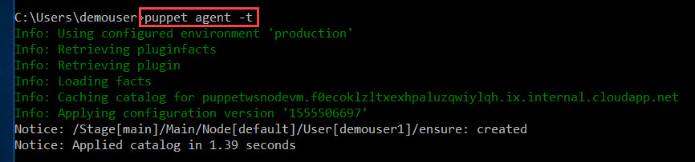

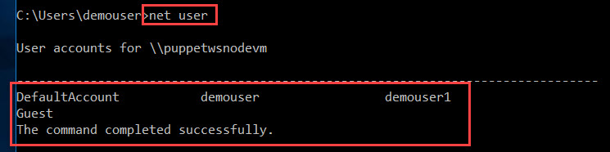

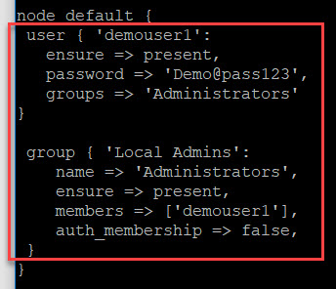

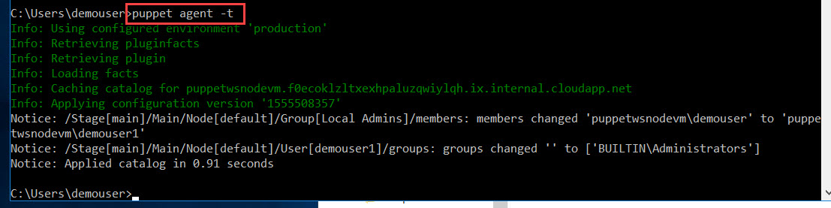

**Installing, Updating Softwares**

